Solution to Assignment: 1

An urban area has a population of two million residents. Three competing trunked mobile networks (systems A, B, and C) provide cellular service in this area. System A has 394 cells with 19 channels each, system B has 98 cells with 57 channels each, and system C has 49 cells, each with 100 channels. Find the number of users that can be supported at 2% blocking if each user averages two calls per hour at an average call duration of three minutes. Assuming that all three trunked systems are operated at maximum capacity, compute the percentage market penetration of each cellular provider.

Solution:

System A

Given:

Probability of blocking = 2% = 0.02
Number of channels per cell used in the system, C = 19
Traffic intensity per user, A_{u} = λ H = 2 × (3/60) = 0.1 Erlangs
For GOS = 0.02 and C = 19, from the Erlang B chart,
the total offered traffic( A)= 12.33 Erlangs.
Therefore, the number of users that can be supported per cell is
U = A/ Au = 12.33/0.1 = 123.3≈123
Since there are 394 cells, the total number of subscribers that can
be supported by System A is equal to 123 × 394 = 48462

System B
Given:
Probability of blocking = 2% = 0.02
Number of channels per cell used in the system, C = 57
A_{u} = λ H = 2 × (3/60) = 0.1 Erlangs
For GOS = 0.02 and C = 57, from the Erlang B chart,
the total offered traffic(A) = 46.82 Erlangs.
Therefore, the number of users that can be supported per cell is
U = A/ Au = 46.82/0.1 = 468.2≈468
Since there are 98 cells, the total number of subscribers that can
be supported by System B is equal to 468 × 98 = 45864

System C
Given:
Probability of blocking = 2% = 0.02
Number of channels per cell used in the system, C = 100
A_{u} = λ H = 2 × (3/60) = 0.1 Erlangs
For GOS = 0.02 and C = 100, from the Erlang B chart,
the total carried traffic(A)= 87.97 Erlangs.
Therefore, the number of users that can be supported per cell is
U = A/ Au = 87.97/0.1 = 879.7≈879
Since there are 49 cells, the total number of subscribers that can be
supported by System C is equal to 879 × 49 = 43071

Therefore, total number of cellular subscribers that can be supported
by these three systems are 48,462 + 45,864 + 43,071=137397

the percentage market penetration is equal to
48,462/2,000,000 = 2.423%

Similarly, market penetration of System B is equal to
45,864/2,000,000 = 2.293%

and the market penetration of System C is equal to
43,071/2,000,000 = 2.153%

The market penetration of the three systems combined is equal to
137,397/2,000,000 = 6.869 %

A cellular service provider decides to use a digital TDMA scheme which can tolerate a signal to- interference ratio of 15 dB in the worst case. Find the optimal value of N for
(a) omnidirectional antennas, (b) 120° sectoring, and (c) 60° sectoring. Should sectoring be used? If so, which case (60° or 120°) should be used? (Assume a path loss exponent of n = 4 and consider trunking efficiency.)

Solution

(a)
Given:

Path loss exponent (n)=4
Tolerable signal to interference ratio, 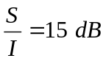

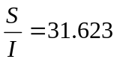

Assuming 6 interferers from the first tire of co-channel cells,

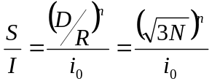

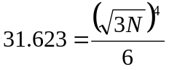
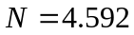

Since we have to choose higher possible value to satisfy the S/I requirement,

N=7

If we calculate S/I from N=7, we get 18.66 dB (Calculate!), which is better than the requirement.

(b)
120° Sectoring

Let us consider first that N=4, (i=2,j=0) .If we see the layout of the cells with N=4, it seems as below.
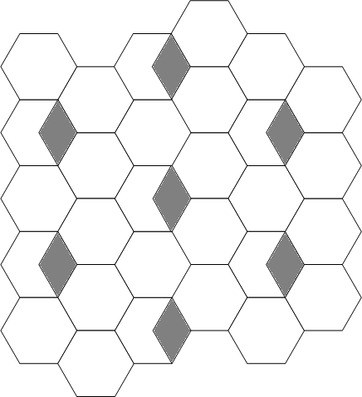

It is clear from the diagram that with 120° sectoring and N=4,there are 2 interferers in the first tier of co-channel cells.

Taking i₀=2 in the expression

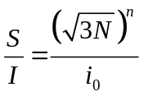
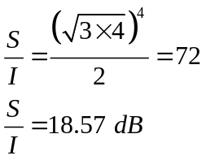

With 120° sectoring, the S/I obtained is better than required. So N=4 can be used.

We have to again check for N=3

Let us consider that N=3, (i=1,j=1) .If we see the layout of the cells with N=3, it seems as below.

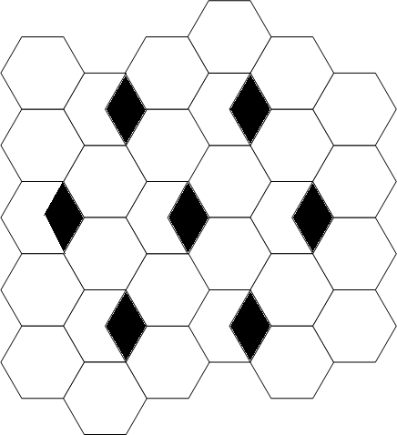

Taking i₀=3 in the expression

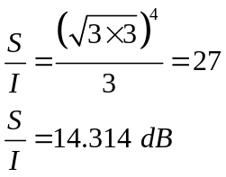

Since it is lower than the required value, N=3 cannot be used.

(b)

60° Sectoring

Let us consider first that N=4, (i=2,j=0) .If we see the layout of the cells with N=4, it seems as below.
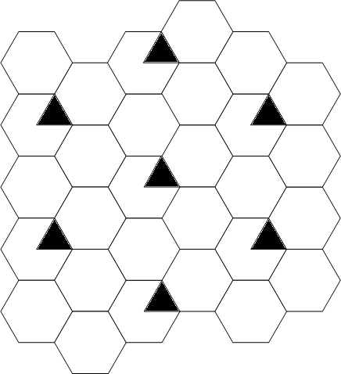

It is clear from the diagram that with 60° sectoring and N=4,there are 1 interferer in the first tier of co-channel cells.

Taking i₀=1 in the expression

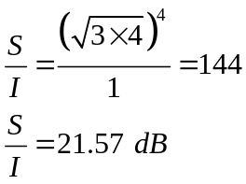

With 60° sectoring, the S/I obtained is better than required. So N=4 can be used.

We have to again check for N=3

Let us consider that N=3, (i=1,j=1) .If we see the layout of the cells with N=3, it seems as below.

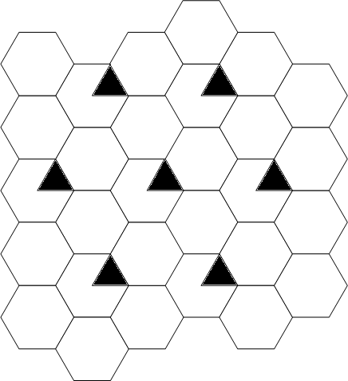

Taking i₀=2 in the expression

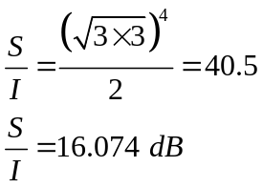

Since it is lower than the required value, N=3 can be used.

To satisfy the S/I requirement, optimum values of N are
N=7 for omnidirectional antenna
N=4 for 120° sectoring
N=3 for 60° sectoring

To check the overall performance, the trunking efficiency must be taken into account.

Assume

Traffic per user=40 mErl=0.04 Erl.
GOS=2%
Total number of traffic channels = 420

- Omnidirectional antenna (N=7)

No of channels per cell=420/7=60
With 2% blocking, Traffic supported per cell = 49.64 Erl

Total no of users supported per cell=(49.64/0.04)=1241

- 120 ° sectoring antenna (N=7)

No of channels per cell=420/7=60
No of channels per sector=60/3=20

With 2% blocking, Traffic supported by one sector = 13.18 Erl

With 2% blocking, Traffic supported per cell= 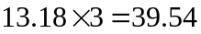 Erl

Total no of users supported per cell=(39.54/0.04)=988.5≈ 988
- 60° sectoring antenna (N=7)

No of channels per cell=420/7=60
No of channels per sector=60/6=10

With 2% blocking, Traffic supported by one sector = 5.048 Erl

With 2% blocking, Traffic supported per cell= 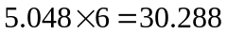 Erl

Total no of users supported per cell=(30.288/0.04)=757.2≈ 757

Reduction in trunking efficiency using 120° sectoring =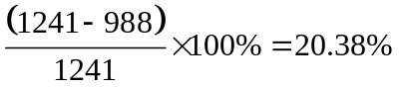

Reduction in trunking efficiency using 60° sectoring =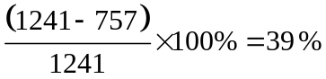

It is clear from above result that if sectoring does not result the lower value of cluster size, then it is harmful as sectoring decreases the trunking efficiency. The advantage is due to reduction in required value of N, which is seen below.

- 120 ° sectoring antenna (N=4)

No of channels per cell=420/4=105
No of channels per sector=105/3=35

With 2% blocking, Traffic supported by one sector = 26.44 Erl
Traffic supported by one cell = 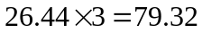

Total no of users supported per cell=(79.32/0.04)=1983

- 60 ° sectoring antenna (N=3)

No of channels per cell=420/3=140
No of channels per sector=140/6=23.33≈23

With 2% blocking, Traffic supported by one sector = 15.76 Erl
Traffic supported by one cell = 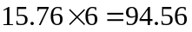

Total no of users supported per cell=(94.56/0.04)=2364

For the given number of channels in the system, 60° sectoring with N=3 gives the largest capacity.

A total of 24 MHz of bandwidth is allocated to a particular FDD cellular telephone
system that uses two 30 kHz simplex channels to provide full duplex voice and control channels. Assume each cell phone user generates 0.1 Erlangs of traffic. Assume Erlang B is used.
(a) Find the number of channels in each cell for a four-cell reuse system.
(b) If each cell is to offer capacity that is 90% of perfect scheduling, find the maximum
number of users that can be supported per cell where omnidirectional antennas are used at each base station.
(c) What is the blocking probability of the system in (b) when the maximum number of
users are available in the user pool?
(d) If each new cell now uses 120° sectoring instead of omnidirectional for each base
station, what is the new total number of users that can be supported per cell for the same blocking probability as in (c)?
(e) If each cell covers five square kilometers, then how many subscribers could be
supported in an urban market that is 50 km × 50 km for the case of omnidirectional base station antennas?
(f) If each cell covers five square kilometers, then how many subscribers could be
supported in an urban market that is 50 km × 50 km for the case of 120° sectored antennas?

Solution:
Total number of channels available in the system=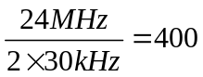
- N=4
Number of channels per cell=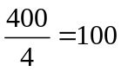
- In perfect scheduling, A=100 Erl

For 90% of perfect scheduling A=90 Erl.
Maximum number of users supported per cell=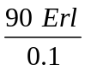=900
(c) From Erlang-B table, the blocking probability (P_{b})=2.837% (using linear interpolation)

A | Blocking Probability (P_{b})
87.97 | 0.02
95.24 | 0.05
90 | ?

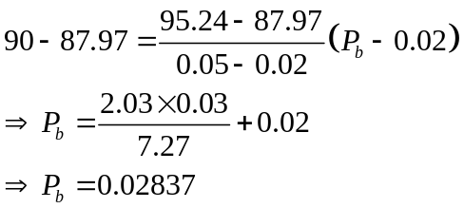
(d)Here we consider the same value of N although N might decrease by sectoring. Since no information is given about S/I requirement, this is not considered.

The number of channels per cell=100

With 120° sectoring, channels per sector =100/3=33.33≈33

Taking P_{b}=2.837 %
From Erlang–B table with interpolation,
Supported traffic (Offered)=A=25.49 Erl.

A | Blocking Probability (P_{b})
24.63 | 0.02
? | 0.0283
27.72 | 0.05

No of users supported per cell=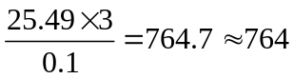

(e) No of cells=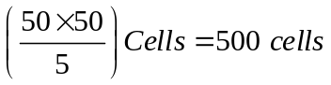
Total number of users supported with omnidirectional antenna=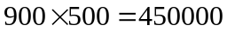

(f) No of cells=
Total number of users supported with 120° sectored antenna =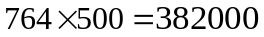

A certain area is covered by a cellular radio system with 84 cells and a cluster size N. 300 voice channels are available for the system. Users are uniformly distributed over the area covered by the cellular system, and the offered traffic per user is 0.04 Erlang. Assume that blocked calls are cleared and the designated blocking probability is Pb =1%.
(a) Determine the maximum carried traffic per cell if cluster size N = 4 is used. Repeat for cluster sizes N = 7 and 12.
(b) Determine the maximum number of users that can be served by the system for a blocking probability of 1% and cluster size N = 4. Repeat for cluster sizes N = 7 and 12.

Solution:

No of cells=84
Total voice channels=300
Offered traffic per user (A_{u}) =0.04 Erl.
Blocking Probability (P_{B})=0.01

N=4
Total voice channels per cell =(300/4)=75
Traffic supported by 1 cell (offered)=A=60.73 Erl.
Carried traffic per cell=A(1-P_{B})=60.73(1-0.01)= 60.123 Erl.

N=7
Total voice channels per cell =(300/7)= 43
Traffic supported by 1 cell (offered)=A=31.66 Erl.
Carried traffic per cell=A(1-P_{B})=31.66(1-0.01)= 31.343 Erl.

N=12
Total voice channels per cell =(300/12)= 25
Traffic supported by 1 cell (offered)=A=16.13 Erl.
Carried traffic per cell=A(1-P_{B})=16.13(1-0.01)= 15.969 Erl.

(b)
for a blocking probability of 1% and cluster size N = 4
Maximum number of users served per cell =A/A_{u}
=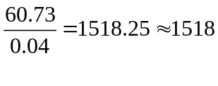
Maximum number of users served per cell that can be served by the system =151884
=127512

for a blocking probability of 1% and cluster size N = 7
Maximum number of users served per cell =A/A_{u}
=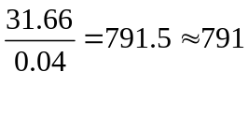
Maximum number of users served per cell that can be served by the system =79184
=66444

for a blocking probability of 1% and cluster size N =12
Maximum number of users served per cell =A/A_{u}
=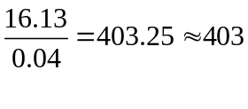
Maximum number of users served per cell that can be served by the system =40384
=33852

A certain city has an area of 1,300 square kilometers and is covered by a cellular system using a seven-cell reuse pattern. Each cell has a radius of four kilometers and the city is allocated 40 MHz of spectrum with a full duplex channel bandwidth of 60 kHz. Assume a GOS of 2% for an Erlang B system is specified. If the offered traffic per user is 0.03 Erlangs, compute (a) the number of cells in the service area, (b) the number of channels per cell, (c) traffic intensity of each cell, (d) the maximum carried traffic, (e) the total number of users that can be served for 2% GOS, (f) the number of mobiles per unique channel (where it is understood that channels are reused), and (g) the theoretical maximum number of users that could be served at one time by the system.
Solution:

Given: Area(A)=1300 km²
Cell Radius(r)= 4km.
The area of full size hexagonal cell is
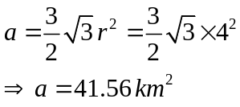

The number of cells in service area=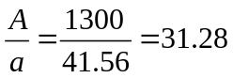

The number of cells in the service area =31

(b) the number of channels per cell

Total number of channels per cell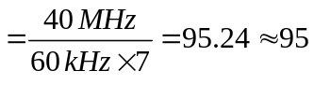
(c) traffic intensity of each cell,

For number of channels =95 and 2%GOS, from Erlang Table,
Traffic intensity that can be supported per cell=83.13 Erl.
(d) the maximum carried traffic,
The carried traffic per cell=offered traffic-lost traffic
=83.83(1-0.02)=82.15 Erl.
Maximum carried traffic in the whole service area (31 Cells)= 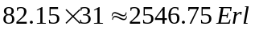

(e) the total number of users that can be served for 2% GOS,

Number of users served per cell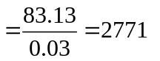
Number of users served in the service area=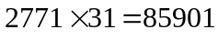

The number of mobiles per unique channel
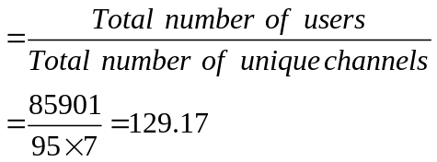

the theoretical maximum number of users that could be served at one time by the system is equal to the total number of channels obtained in the system after frequency reuse

So, theoretical maximum number of users that could be served at one time by the system=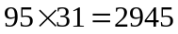

Show that if n = 4, a cell can be split into four smaller cells, each with half the radius and 1/16 of the transmitter power of the original cell. If extensive measurements show that the path loss exponent is three, how should the transmitter power be changed in order to split a cell into four smaller cells? What impact will this have on the cellular geometry? Explain your answer and provide drawings that show how the new cells would fit within the original macrocells. For simplicity use omni directional antennas.

Solution

Given:

Solution:
Let, r₁ be the original radius of the cell before it is splitted; P_{t1} its transmitted power and P_{r1} be the received power at the boundary.
Then, P_{r1} ∝ P_{t1} / r₁^{n}

Q. 2) Show that if n = 4, a cell can be split into four smaller cells, each with half the radius and 1/16 of the transmitter power of the original cell. If extensive measurements show that the path loss exponent is three, how should the transmitter power be changed in order to split a cell into four smaller cells? What impact will this have on the cellular geometry? Explain your answer and provide drawings that show how the new cells would fit within the original macrocells. For simplicity, use omnidirectional antennas.
Solution:
Let, R be the original radius of the cell before it is splitted; P_{t1} its transmitted power and P_{r} be the received power at the boundary.

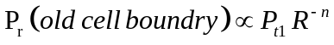

Now, let the cell be splitted with the radius half the original cell; then, it will be divided into 4 cells. This is illustrated in the diagram.

Original Cell When Cell is Splitted
R
a
a/2
a

R/2

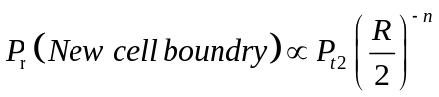

where P_{t1} and P_{t2} are the transmit powers of the larger and smaller cell base stations, respectively, and n is the path loss exponent.

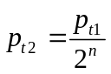
If we take n = 4 and set the received powers equal to each other, then

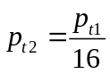
In other words, the transmit power must be reduced by 12 dB in order to fill in the original coverage area with microcells, while maintaining the S/I requirement.

Assuming Square Cell, we can show that when cell radius is made half, its area will be splitted into 4 equal parts.

And when path loss component n = 3,
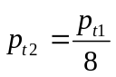
In other words, for n=3,the transmit power must be reduced by 9 dB in order to fill in the original coverage area with microcells, while maintaining the S/I requirement.

